**St. Paul Institute Of Professional Studies**

**Indore (M.P.)**



Department of Computer Science

Project Report

On

“Gully Sport”

Session 2017-18

A Project Report

Submitted in partial fulfilment of the

Requirements for the Graduate Degree in B.C.A.

Semester – VI

Guided By: Submitted By:

Prof. Gourav Rawal Pranshu Arora

(Head, Department Of Computer Science)

Under Taken For

Devi Ahliya Vishwavidyalaya , Indore (M.P.)



St. Paul Institute Of Professional Studies.

**PROFORMA FOR SUGGESTIONS OF BCA PROJECT POROPOSAL**

Enrollment No. : ……………………………

Study Centre:………………………………..

Regional Centre…………..….RCCode:……..……

E-mail:…………..……………………………

Telephone No.:…..……………………………

1. Name and Address of the student ………………………………………………………

2. Title of the Project ………………………………………………………………………

3 Name and Address of the Counsellor ……………………………………………………

4. Education Qualification of the Counsellor MCOM BCOM BCA BSc BBA

5. Working / Teaching experience of the Counsellor ……………………………………..

6. Software used in the Project ……………………………………………………………

Signature of Student

Date:……………….

Suggestions for improving the Project

Signature of Counsellor

Date:…………………..

**CERTIFICATE OF AUTHENTICATED WORK**

This is to certify that the project report entitle **Gully Sports** submitted to **St. Paul Institute Of Professional Studies, Indore** affiliated to **Devi Ahilya Vishwavidyalaya** in partial fulfillment of the requirement for the award of the degree of **BACHLORE OF COMPUTER APPLICATIONS (BCA)** is an original work carried out by **Mr. Pranshu Arora** under my guidance. The matter embodied in this project is authentic and is genuine work done by the student and has not been submitted whether to this University or to any other University / Institute for the fulfilment of the requirement of any course of study.

**INTERNAL EXTERNAL**

**H.O.D PRINCIPAL**

**ACKNOWLEDGMENT**

I would like to avail this opportunity to express our sincere thanks to all those who helped us in making project a success.

My thanks to **Prof.GAURAV RAWAL** [Head of the Department Computer Science] Course Coordinator and Project Guide of **ST.PAUL INSTITUTE OF PROFESSIONAL STUDIES, INDORE** for assisting and providing us liberal encouragement not only during this project but throughout our studies at the College.

I wish to express our profound sense of gratitude to the Head and Faculty members of Computer science Department of **ST.PAUL INSTITUTE OF PROFESSIONAL STUDIES, INDORE** who provided us constant motivation and inspiration throughout the Project, they provided best environment to study and facilities for the guidance all through BACHLORE OF COMPUTER APPLICATION (B.C.A.).

Lastly my thanks to my parents, colleagues and friends for their co-operation.

**Pranshu Arora**

**CONTENTS**

|  |  |  |
| --- | --- | --- |
| 1. | Abstract. | 6 |
| 2. | Introduction. | 7 |
| 3. | Survey of technologies. | 10 |
| 4. | Problem Domain | 11 |
| 5. | Solution Domain | 11 |
| 6. | Application Domain | 12 |
| 7. | Expected Outcome | 12 |
| 8. | System Specification | 13 |
| 9. | Software Description | 13 |
| 10. | Sample Coding | 18 |
| 11. | Output | 57 |
| 12. | Bibliography | 62 |

**Abstract**

‘GULLY SPORTS’ is a proposed project for providing a platform to a community of Sports lovers and for the people who care about their fitness. We support and promote a careful and free life.

**Introduction**

Playing any sports is good for physical and mental health of every individual persons but sometime people didn’t know what they can achieve and where to play or where they can learn the sports.

The main purpose of your website entitled as “GULLY SPORTS” is to encourage people to play sports.

For these we are creating your website which contain all the information of different sports right from best training centre and best coaches, on one click user will find all the information of all different sports in a single site.

Your website includes

* Child development.
* History of sports.
* Importance of sports in life.
* Various sports information.
* Nearby sports training centre.

**Objective:**

The proposed project is a website for sports Knowledge. This will help to encourage people to play sports. It will spread awareness among the people.

### Purpose:

‘GULLY SPORTS’ would have the following key goals :

Provide the site member with an online interface to search for various type of material available in the library under different categories, which can be made accessible through the internet from any where in the world.

Provide the members with ability to select such material and invite some suggestion.

### Scope:

The main scope and deliverables of the project would be to:

* Understand and prepare detailed user requirement and specifications
* Prepare high level and detailed design specifications of the system
* Prepare test plan & test cases
* Develop the system and coding
* Perform unit testing, integration testing and system testing
* Demonstrate a bug free application after suitable modification, if needed.

**SURVEY OF TECHNOLOGIES**

In a web based application like Online ‘GULLY SPORTS’, there is scope for a large number of platforms, languages, web servers and frameworks to choose from. Before selecting from this large array of technologies, the following aspects, which are characteristic to a web based application like this one, have been kept in mind.

* Dynamic page generation
* Performance
* Reliability
* Scalability
* Portability
* Security
* Performance
* Cost constraint

The various technologies available for consideration are as follows:

Client-side programming : HTML, CSS.

Apart from the above, there is a host of other technologies available. However, these were not taken into consideration keeping in view the time constraint of the project

Choice of Web Server: ‘GULLY SPORTS’ is meant for small to medium size portal. Initially we are starting this portal on Notepad and then develop it on Adobe dreamwear.

**Problem Domain**

The problem is encountered when we find the sports website where we can get all information about nearby clubs, camps, grounds and about their couches but we get no information on the web.

The major problem is people not getting proper place to learn and play their favourable sports so when a user has multiple options to explore on the very same platform, he/she has the choice to pick which is of their best interest. Hence a website is definitely a great need and great help.

**Solution Domain**

We propose a website to make this cumbersome task easy and provide user a platform where a large population can be gathered.

And as per the concern the website are created to find proper place to play at their nearby place and those who liked to play sports can get proper guidance and best environment.

**Application Domain**

The scope of the proposed project lies in complete interest of the user. They can run through the options available and prefer their choice of sports. And can get best clubs according to their needs.

**Expected Outcome**

a.) Plethora of choices to the users.

b.) Platform to establish a community of sports and their clubs.

c.) A site for Handy use.

**System Specification**

**Hardware Requirements:**

Processor : AMD E1-2100APU 1.00 GHZ

Clock speed : 500 MHZ

System bus : 32 bits

RAM : 4.15 M.B of RAM

HDD : 40 GB or higher

Monitor : Generic Pnp Monitor

Keyboard : 102keys

Mouse : 2 button mouse.

**Software Requirements:**

OS : XP, VISTA, WINDOS 7, 8, 10

Front End : Notepad, Adobe Dreamweaver

**Software Description**

**1.NOTEPAD**

**Notepad** is a simple [text editor](https://en.wikipedia.org/wiki/Text_editor) for [Microsoft Windows](https://en.wikipedia.org/wiki/Microsoft_Windows) and a basic text-editing program which enables computer users to create documents. It was first released as a [mouse](https://en.wikipedia.org/wiki/Computer_mouse)-based [MS-DOS](https://en.wikipedia.org/wiki/MS-DOS) program in 1983, and has been included in all versions of [Microsoft Windows](https://en.wikipedia.org/wiki/Microsoft_Windows) since [Windows 1.0](https://en.wikipedia.org/wiki/Windows_1.0) in 1985

**Competing Software :-**

Notepad does not require a [lock](https://en.wikipedia.org/wiki/File_locking) on the file it opens, so it can open files already opened by other processes, users, or computers, whereas WordPad cannot. Also, since Notepad lacks advanced formatting functionality, many people find its simple, [minimalistic](https://en.wikipedia.org/wiki/Minimalism_(computing)) [user interface](https://en.wikipedia.org/wiki/User_interface) (whose look has never changed since Windows 3.1 and whose [menus](https://en.wikipedia.org/wiki/Menu_(computing)) were last altered in Windows XP, when "Format" and "View" replaced "Search") faster and easier to use for basic text operations. The [MS-DOS Editor](https://en.wikipedia.org/wiki/Edit.com), especially as updated in Windows 95, where it became an [MDI](https://en.wikipedia.org/wiki/Multiple_document_interface) application, also provides many features never offered by Notepad.

## There are many third-party replacements for Notepad with additional functionality, including both [free software](https://en.wikipedia.org/wiki/Free_software) (e.g. [Notepad++](https://en.wikipedia.org/wiki/Notepad%2B%2B) and [Notepad2](https://en.wikipedia.org/wiki/Notepad2)) and [freeware](https://en.wikipedia.org/wiki/Freeware) (e.g. [TED Notepad](https://en.wikipedia.org/wiki/TED_Notepad)).

## Notepad lacks many features available in other text editors, basic features such as Unix-format [newlines](https://en.wikipedia.org/wiki/Newline), block-select, and [MDI](https://en.wikipedia.org/wiki/Multiple_document_interface), and it lacks full support for line wrapping.

## Notepad being a basic text editor, advanced features are also missing: [syntax coloring](https://en.wikipedia.org/wiki/Syntax_coloring), [code folding](https://en.wikipedia.org/wiki/Code_folding), [regular expressions](https://en.wikipedia.org/wiki/Regular_expressions), [macros](https://en.wikipedia.org/wiki/Macro_(computer_science)), support of [codepages](https://en.wikipedia.org/wiki/Codepage) and [color schemes](https://en.wikipedia.org/wiki/Color_scheme" \o "Color scheme).

# **2. Adobe Dreamweaver**

# **Adobe Dreamweaver** is a [proprietary](https://en.wikipedia.org/wiki/Proprietary_software) [web development](https://en.wikipedia.org/wiki/Web_development) tool from [Adobe Systems](https://en.wikipedia.org/wiki/Adobe_Systems). It was created by [Macromedia](https://en.wikipedia.org/wiki/Macromedia) in 1997and developed by them until Macromedia was acquired by Adobe Systems in 2005.

# Adobe Dreamweaver is available for [macOS](https://en.wikipedia.org/wiki/MacOS) and for [Windows](https://en.wikipedia.org/wiki/Windows).

# Following Adobe's acquisition of the Macromedia product suite, releases of Dreamweaver subsequent to version 8.0 have been more compliant with [W3C](https://en.wikipedia.org/wiki/World_Wide_Web_Consortium) standards. Recent versions have improved support for [Web](https://en.wikipedia.org/wiki/World_Wide_Web) technologies such as [CSS](https://en.wikipedia.org/wiki/Cascading_Style_Sheets), [JavaScript](https://en.wikipedia.org/wiki/JavaScript), and various [server-side scripting](https://en.wikipedia.org/wiki/Server-side_scripting) [languages](https://en.wikipedia.org/wiki/Programming_language) and [frameworks](https://en.wikipedia.org/wiki/Software_framework) including [ASP](https://en.wikipedia.org/wiki/Active_Server_Pages) (ASP JavaScript, ASP VBScript, ASP.NET C#, ASP.NET VB), [ColdFusion](https://en.wikipedia.org/wiki/ColdFusion), [Scriptlet](https://en.wikipedia.org/wiki/Scriptlet" \o "Scriptlet), and [PHP](https://en.wikipedia.org/wiki/PHP).

## 51o+BLpZRyL._SX342_.jpg

## **Features :-**

# Adobe Dreamweaver CC is a web design and development application that combines a visual design surface known as Live View and a code editor with standard features such as [syntax highlighting](https://en.wikipedia.org/wiki/Syntax_highlighting), [code completion](https://en.wikipedia.org/wiki/Code_completion), and code collapsing as well as more sophisticated features such as real-time [syntax checking](https://en.wikipedia.org/wiki/Syntax_analysis#Programming_languages) and code introspection for generating code hints to assist the user in writing code. Combined with an array of site management tools, Dreamweaver lets its users design, code and manage websites, as well as mobile content. Dreamweaver is an [Integrated Development Environment](https://en.wikipedia.org/wiki/Integrated_Development_Environment) (IDE) tool. You can live preview of changes for the frontend. Dreamweaver is positioned as a versatile web design and development tool that enables visualization of web content while coding.

# Dreamweaver, like [other HTML editors](https://en.wikipedia.org/wiki/Comparison_of_WYSIWYG_HTML_editors#Editor_features), edits [files](https://en.wikipedia.org/wiki/Computer_file) locally then uploads them to the remote web server using [FTP](https://en.wikipedia.org/wiki/File_Transfer_Protocol), [SFTP](https://en.wikipedia.org/wiki/SSH_file_transfer_protocol), or [WebDAV](https://en.wikipedia.org/wiki/WebDAV). Dreamweaver CS4 now supports the [Subversion (SVN)](https://en.wikipedia.org/wiki/Subversion_(software)) version control system.

# Since version 5, Dreamweaver supports [syntax highlighting](https://en.wikipedia.org/wiki/Syntax_highlighting) for the following languages [out of the box](https://en.wikipedia.org/wiki/Out_of_the_box_(feature)):

* [ActionScript](https://en.wikipedia.org/wiki/ActionScript)
* [Active Server Pages](https://en.wikipedia.org/wiki/Active_Server_Pages) (ASP).
* [C#](https://en.wikipedia.org/wiki/C_Sharp_(programming_language))
* [Cascading Style Sheets](https://en.wikipedia.org/wiki/Cascading_Style_Sheets) (CSS)
* [ColdFusion](https://en.wikipedia.org/wiki/ColdFusion)
* EDML
* [Extensible HyperText Markup Language](https://en.wikipedia.org/wiki/Extensible_HyperText_Markup_Language) (XHTML)
* [Extensible Markup Language](https://en.wikipedia.org/wiki/Extensible_Markup_Language) (XML)
* [Extensible Stylesheet Language Transformations](https://en.wikipedia.org/wiki/Extensible_Stylesheet_Language_Transformations) (XSLT)
* [HyperText Markup Language](https://en.wikipedia.org/wiki/HyperText_Markup_Language) (HTML)
* [Java](https://en.wikipedia.org/wiki/Java_(programming_language))
* [JavaScript](https://en.wikipedia.org/wiki/JavaScript)
* [PHP](https://en.wikipedia.org/wiki/PHP)
* [Visual Basic](https://en.wikipedia.org/wiki/Visual_Basic) (VB)
* Visual Basic Script Edition ([VBScript](https://en.wikipedia.org/wiki/VBScript))
* [Wireless Markup Language](https://en.wikipedia.org/wiki/Wireless_Markup_Language) (WML)

Support for [ASP.NET](https://en.wikipedia.org/wiki/ASP.NET) and [JavaServer Pages](https://en.wikipedia.org/wiki/JavaServer_Pages" \o "JavaServer Pages) was dropped in version CS5.

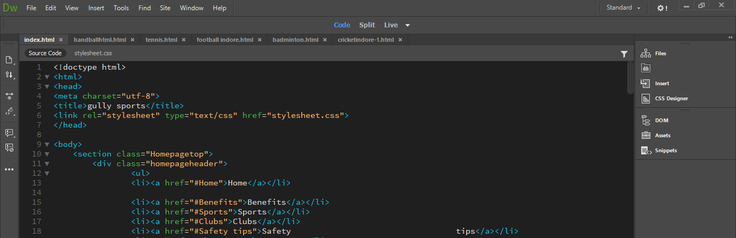

**Sample Coding**

**Home Page.html**

**<!doctype html>**

**<html>**

**<head>**

**<meta charset="utf-8">**

**<title>gully sports</title>**

**<link rel="stylesheet" type="text/css" href="stylesheet.css">**

**</head>**

**<body>**

**<section class="Homepagetop">**

**<div class="homepageheader">**

**<ul>**

**<li><a href="#Home">Home</a></li>**

**<li><a href="#Benefits">Benefits</a></li>**

**<li><a href="#Sports">Sports</a></li>**

**<li><a href="#Clubs">Clubs</a></li>**

**<li><a href="#Safety tips">Safety tips</a></li>**

**<li><a href="#About us">About us</a></li>**

**</ul>**

**</div>**

**<img src="images/gullysportslogo.jpg" alt="">**

**</section>**

**<section class="Home" id="Home">**

**<div class="hometext">**

**<br>**

**<h1> Gully sports</h1>**

**<p> find anything regarding sports of indore</p>**

**</div>**

**</section>**

**<section class="Why">**

**<div class="Whyplay">**

**<h1> Reason why should we must play any sports </h1>**

**<p> According to the United Nations Sports for Development and Peace, physical activity plays an important role in the development of overall health**

**and prevents various diseases. Apart from preventing diseases, playing sports is an excellent physical activity and thus aids in improving the functional capabilities**

**of the body. Sports are not only beneficial to young people, but also for older generations. However, it is always good to start early. Kids should be encouraged to**

**participate in playing sports at school or at social events. When playing a sport, children have the opportunity to show their skills, gain greater self-awareness, and**

**enjoy an activity that they love the most. Provides consistent exercise, Team sports commits children to regular exercise, which helps boost immunity and contributes**

**to overall physical health.</p>**

**<h1>Parents should push their kid to play sports</h1>**

**<p class="para1">**

**<img class="imagechildcom" src="images/gaming-addiction-autisme.jpg" alt="">**

**In the era of online computing childrens now a days sit in front of a TV or computer screen for four and a half hours a day, alarming research reveals.Youngsters now**

**spend an average of one hour and 50 minutes online and two hours 40 minutes in front of the television every day. A report released by research firm ChildWise**

**suggests that screens are increasingly turning into electronic babysitters and young people are spending more time plugged in than ever.**

**<br>**

**<span class="highligh" >It found that children spend more time in front of a screen in one day than they spend exercising in the entire**

**week.</span>**

**<br>**

**The worrying research found that 97 per cent of 11 to 16-year-olds own a mobile phone – eight per cent more than the percentage of adults who own one.**

**<br>**

**I think kids should play sports for many reasons! For example FUN, academic progress, and<span class="highligh">**

**a break from electronics.</span>**

**<br>**

**<a href="whyshouldplay.html"> <button class="button1">**

**Read more**

**</button>**

**</a>**

**</p>**

**</div>**

**</section>**

**<section class="Benefits" id="Benefits">**

**<div>**

**<h1>Surprising Benefits Of Playing Sports </h1>**

**<p>The health benefits of playing sports include proper weight management, efficient functioning of the heart, controlled diabetes, lower**

**cholesterol levels, improved blood circulation, and lower hypertension and stress levels. It helps in the toning of muscles and strengthening of bones. It also brings**

**positive energy, discipline, and helps in building self-esteem and mutual respect.**

**Playing sports is a favorite activity for many people around the world. It provides us with enjoyment and also freshens up our mind. However, playing**

**sports is actually more than running, jumping, or kicking a ball on the field. Indulging in sports helps our body function smoothly and more efficiently. Sports**

**involve the activity of each and every muscle in our body. This strengthens the body and promotes good health.**

**</p>**

**<a href="Benefitsofsports.html"> <button class="button2">**

**More benefits**

**</button>**

**</a>**

**</div>**

**</section>**

**<section class="sports" id="Sports">**

**<idv>**

**<h1>Sports</h1>**

**<p><img class="sportsimage" src="images/sports.png" alt="">**

**Sports includes all forms of competitive physical activity or games which through casual or organised participation, aim to use, maintain or**

**improve physical ability and skills while providing enjoyment to participants, and in some cases, entertainment for spectators. Usually the contest or game is between**

**two sides, each attempting to exceed the other. Some sports allow a tie game; others provide tie-breaking methods, to ensure one winner and one loser. A number of such**

**two-sided contests may be arranged in a tournament producing a champion. Many sports leagues make an annual champion by arranging games in a regular sports season,**

**followed in some cases by playoffs. Hundreds of sports exist, from those between single contestants, through to those with hundreds of simultaneous participants,**

**either in teams or competing as individuals. In certain sports such as racing, many contestants may compete, each against each other, with one winner.</p>**

**</idv>**

**<h1>Various Sports</h1>**

**<h2>Cricket</h2>**

**<p><img class="sportsimage" src="images contain/sports section/cricket-wicket.jpg" alt="">**

**Cricket is a bat-and-ball game played between two teams of eleven players each on a cricket field, at the centre of which is a rectangular 20-**

**metre (22-yard) pitch with a target at each end called the wicket (a set of three wooden stumps upon which two bails sit). Each phase of play is called an innings,**

**during which one team bats, attempting to score as many runs as possible, whilst their opponents bowl and field, attempting to minimise the number of runs scored. When**

**each innings ends, the teams usually swap roles for the next innings (i.e. the team that previously batted will bowl/field, and vice versa). The teams each bat for one**

**or two innings, depending on the type of match. The winning team is the one that scores the most runs, including any extras gained (except when the result is not a**

**win/loss result).**

**<a href=""> <button class="button2">**

**Read more**

**</button>**

**</a>**

**</p>**

**<h2> Football</h2>**

**<p><img class="sportsimage" src="images contain/sports section/football.jpg" alt="">**

**Football is a family of team sports that involve, to varying degrees, kicking a ball with a foot to score a goal. Unqualified, the word football is understood to refer**

**to whichever form of football is the most popular in the regional context in which the word appears. Sports commonly called football in certain places include:**

**association football (known as soccer in some countries); gridiron football (specifically American football or Canadian football); Australian rules football; rugby**

**football (either rugby league or rugby union); and Gaelic football.[1][2] These different variations of football are known as football codes.**

**<a href=""> <button class="button2">**

**Read more**

**</button>**

**</a>**

**</p>**

**<h2>handball</h2>**

**<p><img class="sportsimage" src="images contain/sports section/handball.jpg" alt="">**

**Handball is a team sport in which two teams of seven players each (six outfield players and a goalkeeper) pass a ball using their hands with the aim**

**of throwing it into the goal of the other team. A standard match consists of two periods of 30 minutes, and the team that scores more goals wins.**

**Modern handball is played on a court 40 by 20 metres (131 by 66 ft), with a goal in the middle of each end. The goals are surrounded by a 6-meter (20 ft) zone where**

**only the defending goalkeeper is allowed; goals must be scored by throwing the ball from outside the zone or while "diving" into it. The sport is usually played**

**indoors, but outdoor variants exist in the forms of field handball and Czech handball (which were more common in the past) and beach handball. The game is fast and**

**high-scoring: professional teams now typically score between 20 and 35 goals each, though lower scores were not uncommon until a few decades ago. Body contact is**

**permitted by the defenders trying to stop the attackers from approaching the goal.**

**<br><a href=""> <button class="button2">**

**Read more**

**</button>**

**</a>**

**</p>**

**<h2>Tennis</h2>**

**<p>**

**<img class="sportsimage" src="images contain/sports section/tennis.jpg" alt="">**

**Tennis is a racket sport that can be played individually against a single opponent (singles) or between two teams of two players each (doubles). Each player**

**uses a tennis racket that is strung with cord to strike a hollow rubber ball covered with felt over or around a net and into the opponent's court. The object of the**

**game is to play the ball in such a way that the opponent is not able to play a valid return. The player who is unable to return the ball will not gain a point, while**

**the opposite player will.**

**Tennis is an Olympic sport and is played at all levels of society and at all ages. The sport can be played by anyone who can hold a racket, including wheelchair users.**

**The modern game of tennis originated in Birmingham, England, in the late 19th century as lawn tennis.[1] It had close connections both to various field (lawn) games**

**such as croquet and bowls as well as to the older racket sport today called real tennis. During most of the 19th century, in fact, the term tennis referred to real**

**tennis, not lawn tennis: for example, in Disraeli's novel Sybil (1845), Lord Eugene De Vere announces that he will "go down to Hampton Court and play tennis.**

**<a href=""> <button class="button2">**

**Read more**

**</button>**

**</a>**

**</p>**

**<h2>Badminton</h2>**

**<p>**

**<img class="sportsimage" src="images contain/sports section/malaysia-s-lee-chong-wei-hits-a-shot-against-china-s-chen-long-during-the-men-s-**

**singles-final-at-the-hong-kong-open-badminton-tournament-in-hong-kong-on-november-26-2017-15117012138.jpg" alt="">**

**Badminton is a racquet sport played using racquets to hit a shuttlecock across a net. Although it may be played with larger teams, the most common forms of the**

**game are "singles" (with one player per side) and "doubles" (with two players per side). Badminton is often played as a casual outdoor activity in a yard or on a**

**beach; formal games are played on a rectangular indoor court. Points are scored by striking the shuttlecock with the racquet and landing it within the opposing side's**

**half of the court.**

**<a href=""> <button class="button2">**

**Read more**

**</button>**

**</a>**

**</p>**

**<h2>Basketball</h2>**

**<p>**

**<img class="sportsimage" src="images contain/sports section/basketball.jpg" alt="">**

**Basketball is a limited-contact sport played on a rectangular court. While most often played as a team sport with five players on each side, three-on-three,**

**two-on-two, and one-on-one competitions are also common. The objective is to shoot a basketball (approximately 9.4 inches (24 cm) in diameter) through a hoop 18 inches**

**(46 cm) in diameter and 10 feet (3.048 m) high that is mounted to a backboard at each end of the court. The game was invented in 1891 by Dr. James Naismith.**

**A team can score a field goal by shooting the ball through the basket being defended by the opposition team during regular play. A field goal scores three points for**

**the shooting team if the player shoots from behind the three-point line, and two points if shot from in front of the line. A team can also score via free throws, which**

**are worth one point, after the other team is assessed with certain fouls. The team with the most points at the end of the game wins, but additional time (overtime) is**

**mandated when the score is tied at the end of regulation. The ball can be advanced on the court by passing it to a teammate, or by bouncing it while walking or running**

**(dribbling). It is a violation to lift, or drag, one's pivot foot without dribbling the ball, to carry it, or to hold the ball with both hands then resume dribbling.**

**<a href=""> <button class="button2">**

**Read more**

**</button>**

**</a>**

**</p>**

**</section>**

**<section class="Club" id="Clubs">**

**<div>**

**<h1> Sports clubs in indore</h1>**

**<h2>Category of sports</h2>**

**<p> Click on the sports image in which you are intrested.<br>on clicking you will find the clubs of that particular sports.**

**</p>**

**<a href="badminton.html"> <img src="images contain/clubs section/badminton-1-638.jpg" alt=""></a>**

**<a href="cricketindore-1.html"><img src="images contain/clubs section/cricket.jpg" alt=""></a>**

**<a href="football indore.html"> <img src="images contain/clubs section/football.jpg" alt=""></a>**

**<a href="tennis.html"> <img src="images contain/clubs section/tennis.jpg" alt=""></a>**

**<a href="handballhtml.html"> <img src="images contain/clubs section/handball.png" alt=""></a>**

**<a href="basketballindore.html"> <img src="images contain/clubs section/basketball.jpg" alt=""></a>**

**</div>**

**</section>**

**<section class="Safety tips" id="Safety tips">**

**<div>**

**<h1> Safety tips </h1>**

**<h2>Play under Expert Supervision</h2>**

**<p>Play under Expert Supervision,It is very important to be careful when participating in physical activities like sports. Playing them by implementing the**

**wrong techniques can have harmful effects on your health. Try playing sports under the supervision of experienced players in the beginning and take their advice on how**

**to play the game without getting hurt.</p>**

**<h2>Stretching and Warm-up Exercises</h2>**

**<p>Stretching and warm up exercises are a must in order to prevent cramps and sprains. Stretching prepares the body, brain, and mind for the physical**

**activity involved in the sport. The blood flow increases in the muscle when one stretches and this increases the elasticity of muscles, which prevents muscle**

**injuries.</p>**

**<h2>Stay Hydrated</h2>**

**<p>It is very important to remain well-hydrated in order to prevent dehydration from affecting the quality of your performance and your health. One**

**must carry a sufficient amount of water if any sport is planned somewhere away from home. Drink water throughout the session in small quantities.</p>**

**<h2>Relax after the Game</h2>**

**<p>It is important to rest after playing any sport. It helps relax your body and mind. The heart rate normalizes and the muscles relax. Cold fluids**

**should be consumed after playing an intense sport. They help in cooling down the body and also in preventing heat-related illnesses. These types of illnesses are**

**serious issues that affect many people, even professional athletes. It causes nausea, unsteadiness, and in certain instances, it can even make a person collapse**

**completely. Prevention is the only way that this kind of situation can be dealt with, so make sure you drink plenty of water and keep your temperature down.</p>**

**</div>**

**</section>**

**<section class="aboutus" id="About us">**

**<h1>About us </h1>**

**<p><img src="images/aboutus.png" alt="">**

**<br>**

**<br>**

**Gully sports indore - A sports encouragement site which help users to find different sports with there trainig center at one place.**

**The main purpose of making Gully sports indore is to show the importance of sports in life.</p>**

**</section>**

**</body>**

**</html>**

**Badminton.html page**

**<!doctype html>**

**<html>**

**<head>**

**<meta charset="utf-8">**

**<title>Untitled Document</title>**

**<link rel="stylesheet" type="text/css" href="stylesheet.css">**

**</head>**

**<body>**

**<section class="Badminton">**

**<h1> Badminton training centers in indore</h1>**

**<h2> Atal Bihari Vajpayee Khel School</h2>**

**<p>**

**<img src="images contain/badminton/IMG\_20180404\_174424.jpg" alt="">**

**<img src="images contain/badminton/IMG\_20180404\_174557.jpg" alt="">**

**<br>**

**practice timing.**

**<br>**

**Morning -**

**6am to 8am.**

**<br>**

**Evening- 5pm to 8 pm.**

**<br>**

**Loaction of club**

**<a href="https://www.google.co.in/maps/search/atal+khel+ground+indore/@22.7556652,75.8696221,13z/data=!3m1!4b1">Atal Bihari Vajpayee Khel School**

**</a></p>**

**<h2> SPIPS badminton academy indore</h2>**

**<p>**

**<img src="images contain/spips badminton/0.jpg" alt="">**

**<img src="images contain/spips badminton/1.jpg" alt="">**

**<img src="images contain/spips badminton/2.jpg" alt="">**

**<br>- practice timing.**

**<br>**

**Morning -**

**6am to 8am.**

**<br>**

**Evening- 5pm to 8 pm.**

**<br>**

**Loaction of club Geeta Bhavan, 7/1, Boundry Road, Near St. Paul Higher Secondary School, Lalaram Nagar, Indore, Madhya Pradesh 452001.**

**<br>**

**for location on map click here.**

**<a href="https://www.google.co.in/maps/place/St.+Paul+Institute+Of+Professional+Studies/@22.7143894,75.888112,17z/data=!3m1!4b1!4m5!3m4!1s0x3962fd2fda216b61:0xfa3365c7f9cdcbd6!8m2!3d22.7143894!4d75.8903007">SPIPS badminton academy indore**

**</a>**

**</p>**

**<h2> Yeshwant club indore</h2>**

**<p>**

**<img src="images contain/yeshwant club/the-yeshwant-club-race-course-road-indore-sports-clubs-2dcrcx7.jpg" alt="">**

**<img src="images contain/yeshwant club/badminton.jpg" alt="">**

**<br>practice timing.**

**<br>**

**Morning -**

**6am to 8am.**

**<br>**

**Evening- 5pm to 8 pm.**

**<br>**

**Loaction of club. Race Course Road, Indore, Madhya Pradesh 452003**

**<br>**

**for location on map click here.**

**<a href="https://www.google.co.in/maps/place/Yeshwant+Club/@22.7239989,75.874623,17z/data=!3m1!4b1!4m5!3m4!1s0x3962fd3ffa2a99f7:0x6a81018fbbd2024d!8m2!3d22.7239989!4d75.8768117">Yeshwant club indore**

**</a>**

**</p>**

**<h2> Abhay prashal indore</h2>**

**<p>**

**<img src="images contain/abhay prashal/images (1).jpg" alt="">**

**<img src="images contain/abhay prashal/images.jpg" alt="">**

**<br>practice timing.**

**<br>**

**Morning -**

**6am to 8am.**

**<br>**

**Evening- 5pm to 8 pm.**

**<br>Loaction of club Race Course Road, Indore, Madhya Pradesh 452003**

**<br> for location on map click here.**

**<a href="https://www.google.co.in/maps/place/Abhay+Prashal+Sports+Club/@22.7250403,75.8756368,17z/data=!3m1!4b1!4m5!3m4!1s0x3962fd3ff5e11a41:0xe08cc0a9fc7ae8a6!8m2!3d22.7250354!4d75.8778255">Abhay prashal indore.**

**</a>**

**</p>**

**</section>**

**</body>**

**</html>**

**Home Page.css**

**/\* CSS Document \*/**

**/\*home page home buttons\*/**

**ul{**

**list-style: none;**

**float :right;**

**padding:10px;**

**margin :0 px;**

**}**

**ul li a{**

**text-decoration: none;**

**font-size: 30px;**

**font-family:georgia;**

**color:black;**

**width:80px;**

**margin: 20px;**

**padding: 10px;**

**border-radius: 4px;**

**text-align: center;**

**height:25px;**

**line-height: 25px;**

**}**

**ul li a:hover{**

**background-color:grey;**

**color:black;**

**}**

**li{**

**display:inline;**

**}**

**.homepageheader{**

**position:absolute;**

**top: 0;**

**padding-top: 30px;**

**width: 100%;**

**}**

**/\***

**\*/**

**/\* home section\*/**

**.Home{**

**background-image:url(images/spor-nedir-950x401.jpg);**

**background-size: 100%;**

**background-repeat: no-repeat;**

**align-items: center;**

**height: 700px;**

**margin-top: 35px;**

**}**

**.hometext h1{**

**font-size: 60px;**

**font-family:helvetica;**

**margin:10px;**

**margin-left:40px;**

**}**

**.hometext p{**

**font-size: 30px;**

**font-family:helvatica;**

**margin:10px;**

**margin-left:40px;**

**}**

**/\* why section\*/**

**.Whyplay h1{**

**font-family:helvetica;**

**font-size: 30px;**

**color:#AF0508;**

**}**

**.Whyplay p{**

**font-family:helvetica;**

**font-size: 20px;**

**}**

**.para1{**

**font-size: 20px;**

**padding:10px;**

**margin:20px;**

**}**

**.imagechildcom{**

**float: left;**

**margin-right:10px;**

**}**

**.highligh**

**{**

**background-color:#AF0508;**

**color:white;**

**}**

**/\* read button \*/**

**.button1{**

**padding:10px;**

**margin:30px;**

**margin-left: 21%;**

**}**

**.button1:hover{**

**background-color: grey;**

**color:white;**

**cursor:pointer;**

**}**

**/\* over here\*/**

**/\* after read more firts why should play page css\*/**

**.whyshouldplay h1{**

**font-size:40px;**

**text-align: center;**

**font-family: helvetica;**

**}**

**.whyshouldplay h2{**

**font-size:40px;**

**text-align: center;**

**font-family: helvetica;**

**}**

**.whyshouldplay p{**

**font-size:20px;**

**color:grey;**

**font-family:"Gill Sans", "Gill Sans MT", "Myriad Pro", "DejaVu Sans Condensed", Helvetica, Arial, "sans-serif";**

**}**

**.whyimage{**

**display:block;**

**margin-left:auto;**

**margin-right:auto;**

**}**

**/\* over here\*/**

**/\*benefits section\*/**

**.Benefits h1{**

**font-family:helvetica;**

**font-size: 30px;**

**}**

**.Benefits p{**

**font-family:helvetica;**

**background-color: white;**

**font-size:20px;**

**line-height:1.5em;**

**padding:20px;**

**border-color:black;**

**border-width:thick;**

**border-style:double;**

**}**

**.button2{**

**padding:10px;**

**margin:30px;**

**margin-left:50%;**

**}**

**.button2:hover{**

**background-color: grey;**

**color:white;**

**cursor:pointer;**

**}**

**/\*over benefits section\*/**

**/\*benefits of sports page css\*/**

**.benefitsofsports h1{**

**font-size: 40px;**

**color: firebrick;**

**font-family: Baskerville, "Palatino Linotype", Palatino, "Century Schoolbook L", "Times New Roman", "serif";**

**}**

**.benefitsofsports h2{**

**font-size:30px;**

**color: firebrick;**

**font-family:Baskerville, "Palatino Linotype", Palatino, "Century Schoolbook L", "Times New Roman", "serif";**

**}**

**.benefitsofsports p{**

**font-size:25px;**

**font-family: "Gill Sans", "Gill Sans MT", "Myriad Pro", "DejaVu Sans Condensed", Helvetica, Arial, "sans-serif";**

**}**

**/\* sports section\*/**

**.sportsimage{**

**float: right;**

**padding:0px;**

**margin:0px;**

**}**

**.sports h1{**

**font-size: 40px;**

**font-family:Baskerville, "Palatino Linotype", Palatino, "Century Schoolbook L", "Times New Roman", "serif";**

**}**

**.sports p{**

**font-size:20px;**

**font-family: helvetica;**

**background-color: yellow;**

**color:darkolivegreen;**

**line-height:1.5em;**

**padding:20px;**

**border-color:white;**

**border-width:thick;**

**border-style:double;**

**}**

**.sports h2{**

**font-size: 30px;**

**color:darkolivegreen;**

**font-family:Baskerville, "Palatino Linotype", Palatino, "Century Schoolbook L", "Times New Roman", "serif";**

**}**

**.Club h1{**

**font-size: 40px;**

**font-family:Baskerville, "Palatino Linotype", Palatino, "Century Schoolbook L", "Times New Roman", "serif";**

**}**

**.Club h2{**

**font-size: 30px;**

**font-family:Baskerville, "Palatino Linotype", Palatino, "Century Schoolbook L", "Times New Roman", "serif";**

**}**

**.Club p{**

**font-size: 30px;**

**color:slateblue;**

**}**

**.Club img{**

**transition: 2s;**

**padding: 40px;**

**}**

**.Club img:hover{**

**cursor:pointer;**

**transform: scale(1.1);**

**}**

**.Safety h1{**

**font-size: 40px;**

**font-family:Baskerville, "Palatino Linotype", Palatino, "Century Schoolbook L", "Times New Roman", "serif";**

**}**

**.Safety h2{**

**font-size: 30px;**

**font-family:Baskerville, "Palatino Linotype", Palatino, "Century Schoolbook L", "Times New Roman", "serif";**

**}**

**.Safety p{**

**font-size: 20px;**

**color:black;**

**background-color: grey;**

**line-height:1.5em;**

**padding:20px;**

**border-color:gainsboro;**

**border-width:thick;**

**border-style:double;**

**border-radius: 20px;**

**font-family:Baskerville, "Palatino Linotype", Palatino, "Century Schoolbook L", "Times New Roman", "serif";**

**}**

**/\* basketballindore\*/**

**.basketball h1 {**

**font-size: 40px;**

**font-family:Baskerville, "Palatino Linotype", Palatino, "Century Schoolbook L", "Times New Roman", "serif";**

**}**

**.basketball h2 {**

**color:crimson;**

**text-align: center;**

**font-size: 30px;**

**font-family:Baskerville, "Palatino Linotype", Palatino, "Century Schoolbook L", "Times New Roman", "serif";**

**}**

**.basketball p {**

**background-color:aquamarine;**

**color:maroon;**

**line-height:1.5em;**

**padding:20px;**

**border-color:white;**

**border-width:thick;**

**border-style:double;**

**font-family:Baskerville, "Palatino Linotype", Palatino, "Century Schoolbook L", "Times New Roman", "serif";**

**}**

**.football h1 {**

**font-size: 40px;**

**font-family:Baskerville, "Palatino Linotype", Palatino, "Century Schoolbook L", "Times New Roman", "serif";**

**}**

**.football h2 {**

**color:crimson;**

**text-align: center;**

**font-size: 30px;**

**font-family:Baskerville, "Palatino Linotype", Palatino, "Century Schoolbook L", "Times New Roman", "serif";**

**}**

**.football p {**

**background-color:aquamarine;**

**color:maroon;**

**line-height:1.5em;**

**padding:20px;**

**border-color:white;**

**border-width:thick;**

**border-style:double;**

**font-family:Baskerville, "Palatino Linotype", Palatino, "Century Schoolbook L", "Times New Roman", "serif";**

**}**

**.Badminton h1 {**

**font-size: 40px;**

**font-family:Baskerville, "Palatino Linotype", Palatino, "Century Schoolbook L", "Times New Roman", "serif";**

**}**

**.Badminton h2 {**

**color:crimson;**

**text-align: center;**

**font-size: 30px;**

**font-family:Baskerville, "Palatino Linotype", Palatino, "Century Schoolbook L", "Times New Roman", "serif";**

**}**

**.Badminton p {**

**background-color:aquamarine;**

**color:maroon;**

**line-height:1.5em;**

**padding:20px;**

**border-color:white;**

**border-width:thick;**

**border-style:double;**

**font-family:Baskerville, "Palatino Linotype", Palatino, "Century Schoolbook L", "Times New Roman", "serif";**

**}**

**.tennis h1 {**

**font-size: 40px;**

**font-family:Baskerville, "Palatino Linotype", Palatino, "Century Schoolbook L", "Times New Roman", "serif";**

**}**

**.tennis h2 {**

**color:crimson;**

**text-align: center;**

**font-size: 30px;**

**font-family:Baskerville, "Palatino Linotype", Palatino, "Century Schoolbook L", "Times New Roman", "serif";**

**}**

**.tennis p {**

**background-color:aquamarine;**

**color:maroon;**

**line-height:1.5em;**

**padding:20px;**

**border-color:white;**

**border-width:thick;**

**border-style:double;**

**}**

**.handball h1 {**

**font-size: 40px;**

**font-family:Baskerville, "Palatino Linotype", Palatino, "Century Schoolbook L", "Times New Roman", "serif";**

**}**

**.handball h2 {**

**color:crimson;**

**text-align: center;**

**font-size: 30px;**

**font-family:Baskerville, "Palatino Linotype", Palatino, "Century Schoolbook L", "Times New Roman", "serif";**

**}**

**.h p {**

**background-color:aquamarine;**

**color:maroon;**

**line-height:1.5em;**

**padding:20px;**

**border-color:white;**

**border-width:thick;**

**border-style:double;**

**}**

**.aboutus h1{**

**text-align: center;**

**font-family: helvetica;**

**font-size:40px;**

**}**

**.aboutus p{**

**float:right;**

**text-align: center;**

**word-spacing: 10px;**

**font-size: 20px;**

**color:white;**

**background-color: Black;**

**line-height:1.5em;**

**padding:20px;**

**font-family: helvetica;**

**}**

**.aboutus img{**

**float: left;**

**padding:0px;**

**margin:0px;**

**}**

**OUTPUT**

**Home page**

**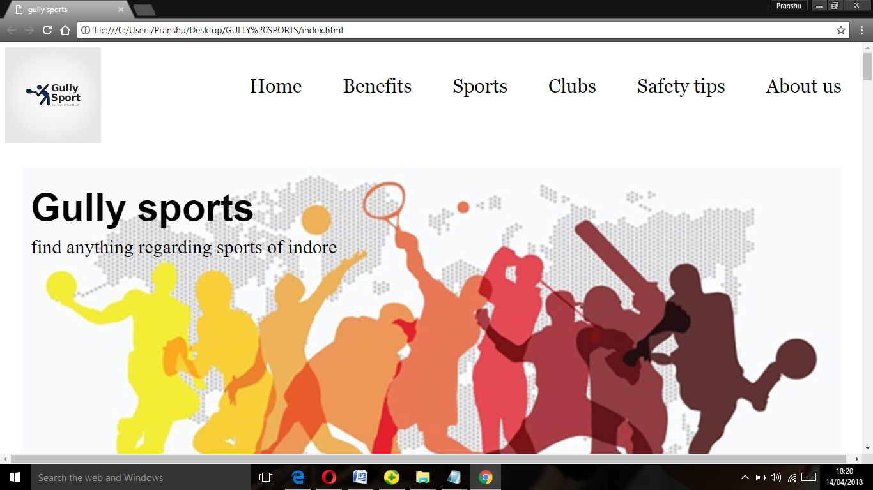**

**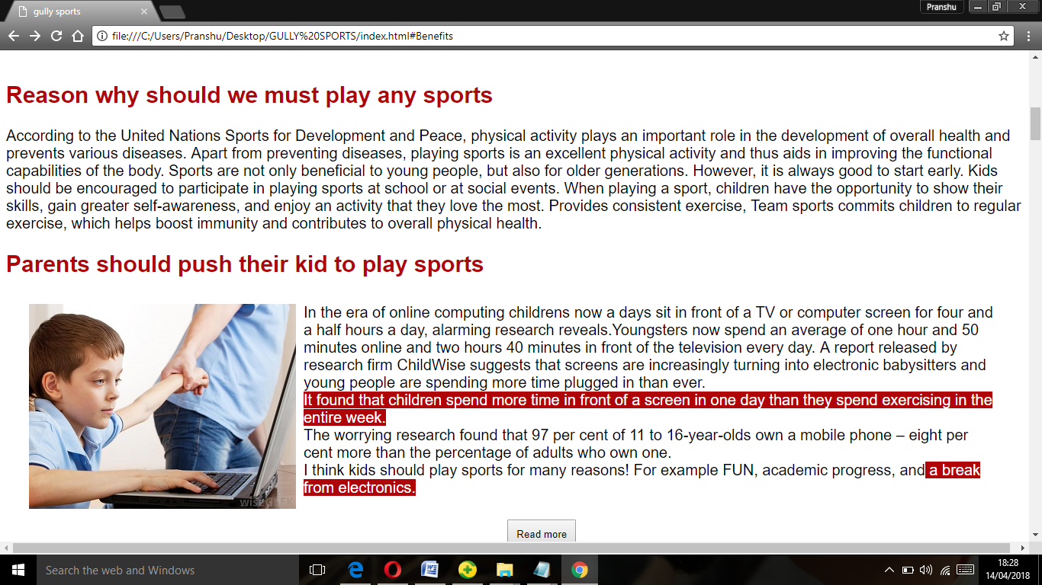**

**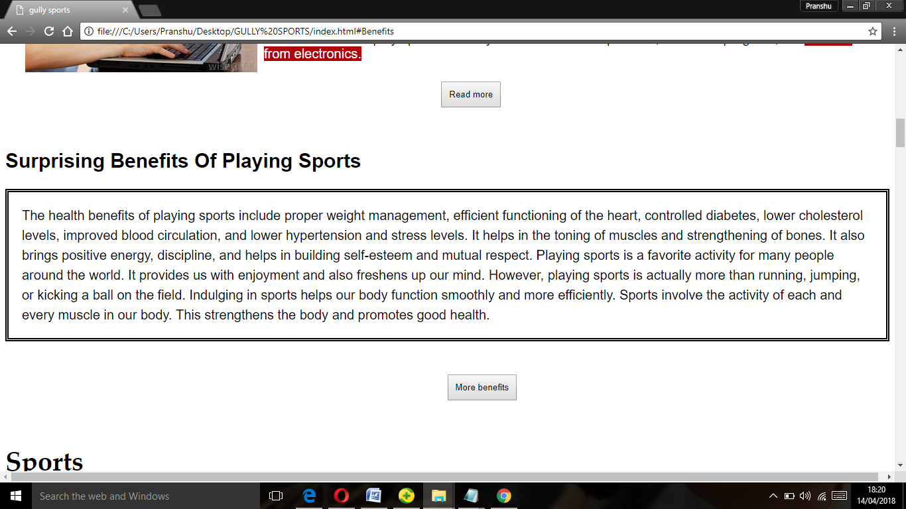**

**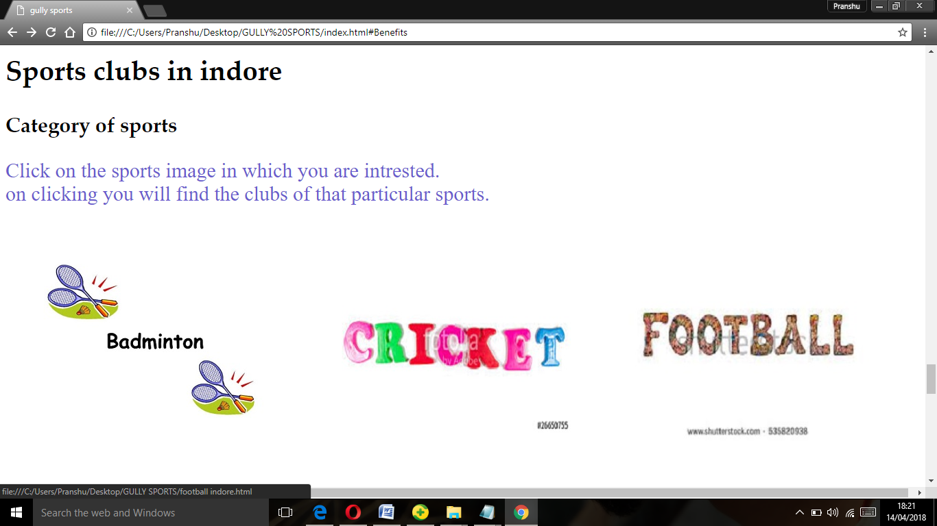**

**Sports Categories**

**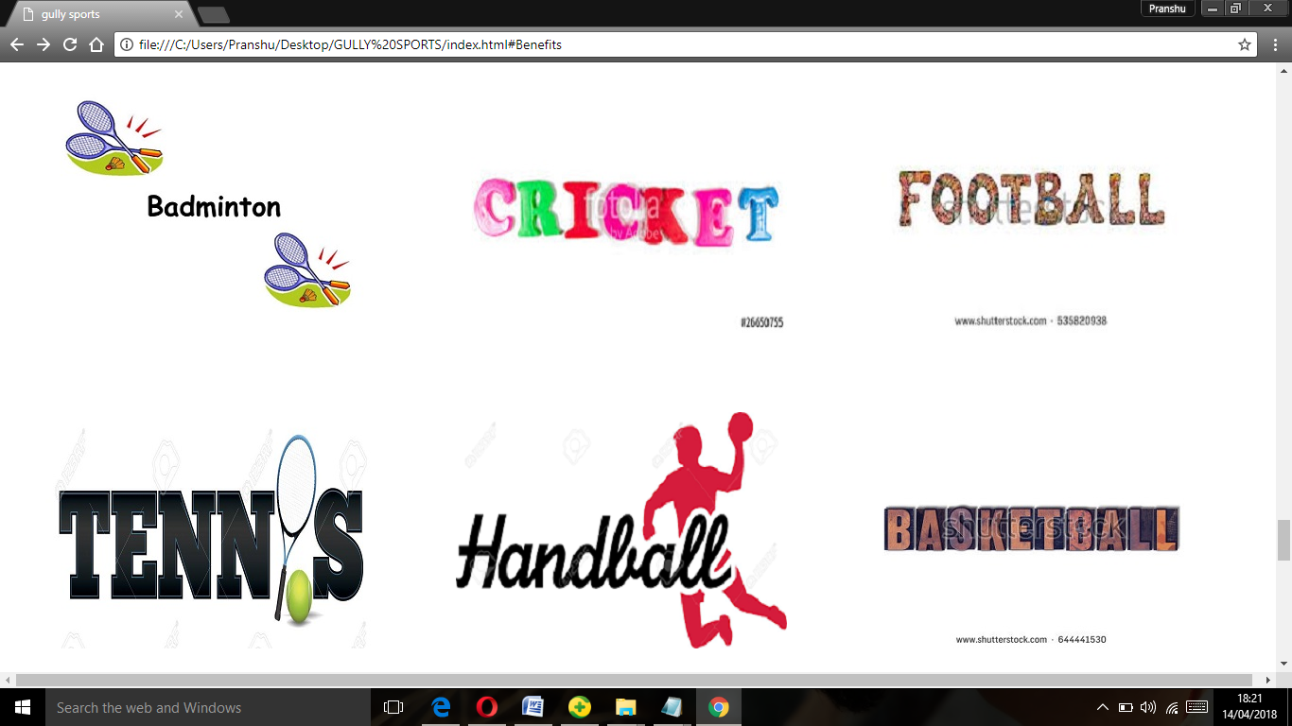**

**Clubs Availability**

**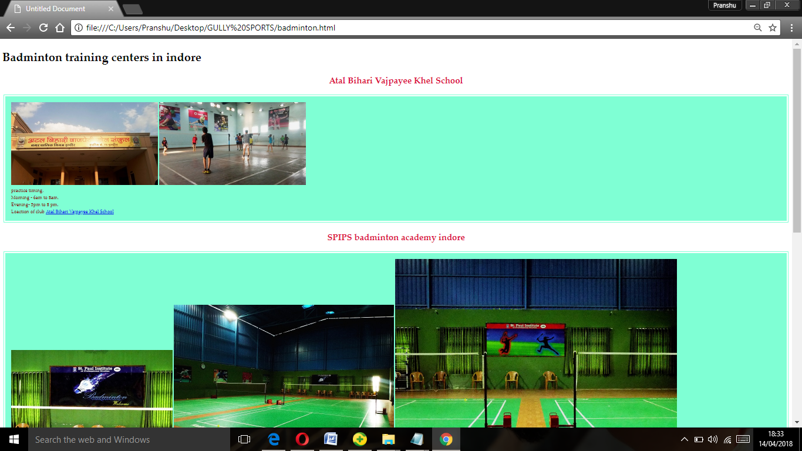**

**Safety tips**

**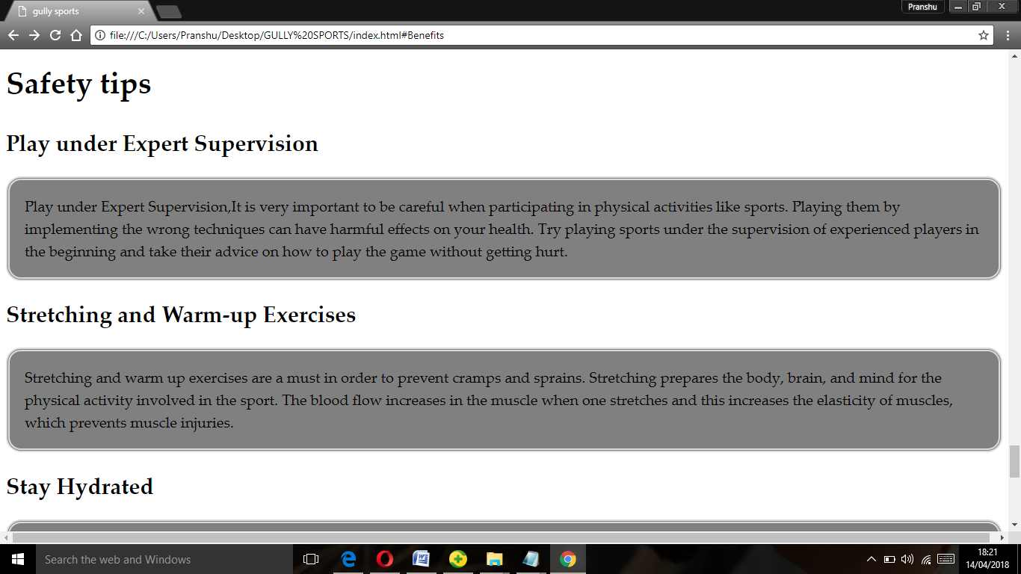**

**About us**

**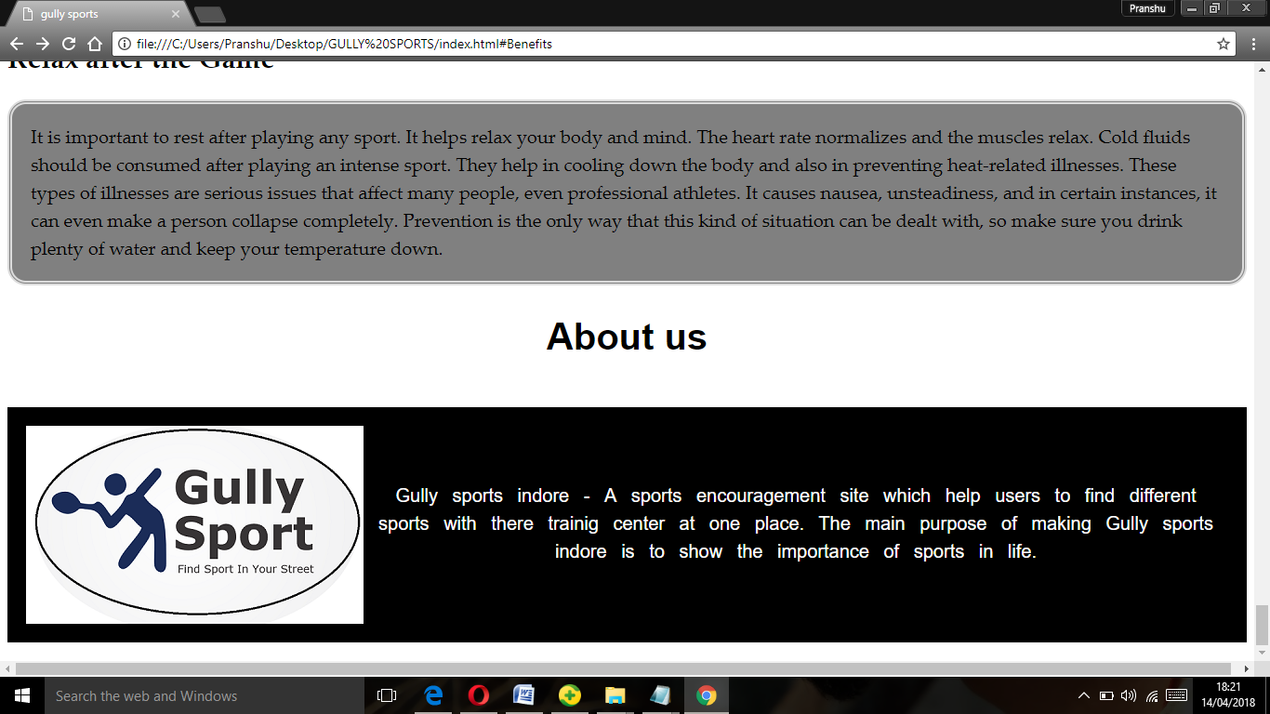**

**Limitation:**

1. Availability of internet connection is compulsory.

2: The images of the Recipes is not provided by us.

3. Latest browser requirement.

**Future Enhancement:**

The performance of the system is proved to be efficient. All the Profiles receive an overall benefit through the system. The system provides flexibility for incorporating new features, which may be necessary in future.

**Conclusion:**

We are confident that our website will help in guiding every human being who love sports. It will help in maintaining a proper health after getting knowledge about playing sports from the site. People will get aware of benefits of sports and will encourage other people also. This will help in creating a healthy society and a healthy country.

**BIBLIOGRAPHY**

* **www.w3schools.com**
* **YouTube channel EJ media.**